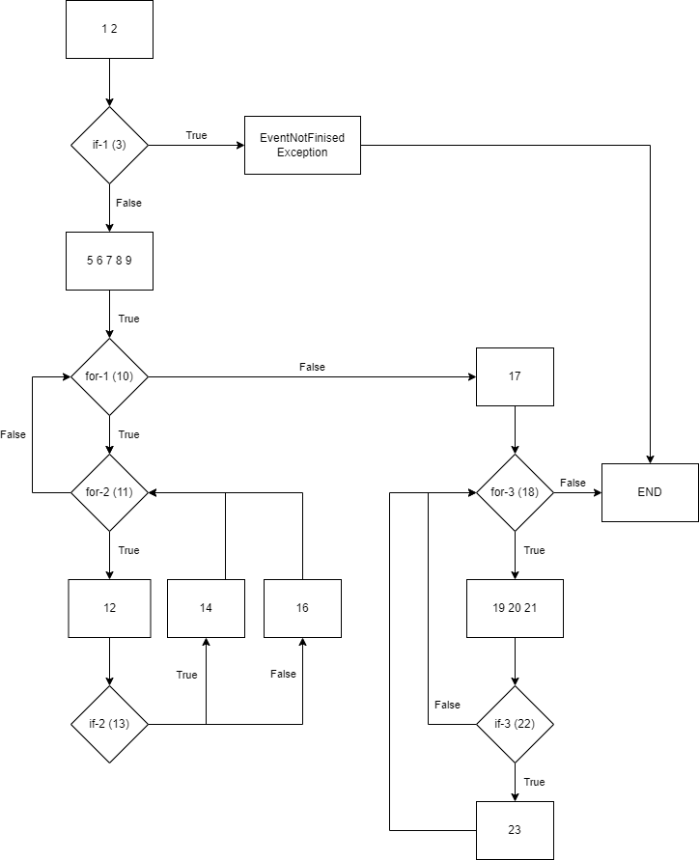

V(G) = 7

Caminos:

1- 1 2 if-1(T) Except. END

2- 1 2 if-1(F) 5 6 7 8 9 for-1(T) for-(F) for-(F) 17 for-3(F) END

3- 1 2 if-1(F) 5 6 7 8 9 for-1(T) for-2(T) 12 if-2(T) 14 for-2(F) for-1(F) 17 for-3(F) END

4- 1 2 if-1(F) 5 6 7 8 9 for-1(T) for-2(T) 12 if-2(F) 16 for-2(F) for-1(F) 17 for-3(F) END

5- 1 2 if-1(F) 5 6 7 8 9 for-1(F) 17 for-3(T) 19 20 21 if-3(T) 23 for-3(F) END

7- 1 2 if-1(F) 5 6 7 8 9 for-1(F) 17 for-3(T) 19 20 21 if-3(F) for-3(F) END

|  |  |  |  |
| --- | --- | --- | --- |
| #caso | Condición entrada | Entrada | Salida |
| 1 | todayDate < eventDate |  | EventNotFinished exception |
| 2 | question.quotes.size() > 0 |  |  |
| 3 | question.quotes.size() > 0  quo.apustuak > 0 |  |  |
| 4 | question.quotes.size() > 0  quo.apustuak > 0  b == True |  |  |
| 5 | question.quotes.size() > 0  quo.apustuak > 0  b == False |  |  |
| 6 |  |  |  |
| 7 |  |  |  |